Eg: Array_Eg11
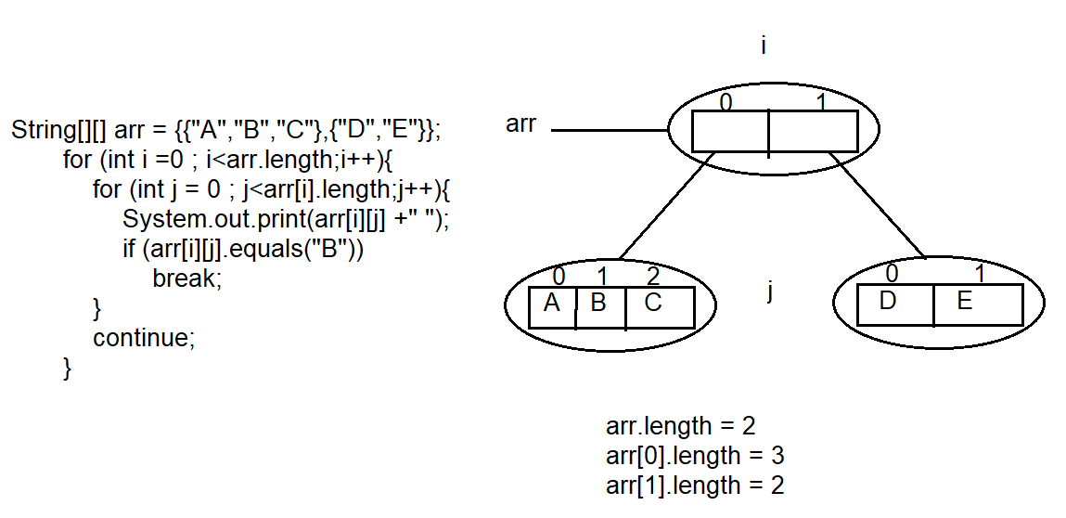

🔁 Code we are talking about
String[][] arr = {{"A","B","C"},{"C","D"}};

for (int i = 0; i < arr.length; i++) {
for (int j = 0; j < arr[i].length; j++) {
System.out.print(arr[i][j] + " ");
if (arr[i][j].equals("B"))
break;
}
continue;
}

▶ OUTER LOOP — ITERATION 1

Step 1: Outer loop starts
i = 0
Current row:
arr[0] = {"A", "B", "C"}

▶ INNER LOOP (Row 0)

▶ INNER ITERATION 1
Step 1: j value
j = 0
Step 2: Pick element
arr[0][0] = "A"
Step 3: Print
Output → A
Step 4: Check condition
"A".equals("B") → false
➡ No break
➡ Continue inner loop

▶ INNER ITERATION 2
Step 1: j value
j = 1
Step 2: Pick element
arr[0][1] = "B"
Step 3: Print
Output → B
Step 4: Check condition
"B".equals("B") → true
➡ break executes
➡ Inner loop stops immediately

End of INNER LOOP (Row 0)

Step 5: continue in outer loop
continue;
➡ Skips remaining outer-loop code
➡ Moves to next outer iteration (i++)

▶ OUTER LOOP — ITERATION 2

Step 1: Outer loop continues
i = 1
Current row:
arr[1] = {"C", "D"}

▶ INNER LOOP (Row 1)

▶ INNER ITERATION 1
Step 1: j value
j = 0
Step 2: Pick element
arr[1][0] = "C"
Step 3: Print
Output → C
Step 4: Check condition
"C".equals("B") → false
➡ Continue inner loop

▶ INNER ITERATION 2
Step 1: j value
j = 1
Step 2: Pick element
arr[1][1] = "D"
Step 3: Print
Output → D
Step 4: Check condition
"D".equals("B") → false
➡ Inner loop ends normally

End of INNER LOOP (Row 1)

Step 5: continue in outer loop
continue;
➡ Moves to next i

▶ OUTER LOOP — ITERATION 3
❌ No iteration
i = 2 → i < arr.length (2) → false
Outer loop ends.

🧠 FINAL OUTPUT
A B C D

❌ NO — continue should NOT always be the last statement
But…

✅ WHEN continue is written,
it must be the last statement that actually runs in that iteration.

🧠 Golden Rule (Very Important)
Once continue executes,
nothing after it in the same loop iteration will run.
So:
- Code can exist after continue
- But that code is unreachable in that iteration

✅ Common & CORRECT usage (continue in middle)
for (int i = 1; i <= 5; i++) {

if (i == 3) {
continue; // skip this iteration
}

System.out.println(i);
}

Execution:
i=1 → print
i=2 → print
i=3 → continue → skip println
i=4 → print
i=5 → print
Output:
1
2
4
5
✔️ Here continue is NOT the last line
✔️ But it acts as the last executed line for that iteration

❌ Useless usage (your previous code)
for (...) {
...
continue;
}
✔️ Valid syntax
❌ No logical use
❌ Same behavior without it

🚨 Compile-time Rule (Important)
This is ILLEGAL ❌
for (...) {
continue;
System.out.println("hello"); // unreachable code
}
👉 Java compiler error:
Unreachable code

🧠 Final Clear Answer
Question | Answer
Should continue be last line? | ❌ Not required
Does code run after continue? | ❌ Never
Is continue at end useful? | ❌ No
Best place for continue? | ✅ Before code you want to skip

🏁 One-line rule to remember
continue ends the current iteration immediately, wherever it appears.

Eg: Array_Eg12
// go through the program.

📌 Given Statements
1) int[] a = new int[];

2) int[][] a = new int[3][4];

3) int[][] a = new int[3][];

4) int[][] a = new int[][4];

5) int[][][] a = new int[3][4][5];

6) int[][][] a = new int[3][4][];

7) int[][][] a = new int[3][][5];

✅ VERY IMPORTANT RULE (Core Rule)
Base index (first dimension) MUST be given
Remaining indexes MAY or MAY NOT be given
📌 Base index = leftmost size

❌ INVALID CASES (1, 4, 7)

❌ 1) int[] a = new int[];
int[] a = new int[]; // ❌ INVALID
Why?
- This is a 1D array
- Base index is missing
- Compiler does NOT know how much memory to allocate
✔ Correct forms:
int[] a = new int[5];
int[] a = {1, 2, 3};

❌ 4) int[][] a = new int[][4];
int[][] a = new int[][4]; // ❌ INVALID
Why?
- Base index (first dimension) is missing
- Second dimension is given
- Java does NOT allow skipping the base index
👉 This violates the rule:
Base index must be specified

❌ 7) int[][][] a = new int[3][][5];
int[][][] a = new int[3][][5]; // ❌ INVALID
Why?
- First index is given ✔
- Second index is missing ❌
- Third index is given ❌
📌 You cannot give an index after skipping one

✅ VALID CASES (2, 3, 5, 6)

✅ 2) int[][] a = new int[3][4];
✔ Base index given
✔ All remaining indexes given

✅ 3) int[][] a = new int[3][];
✔ Base index given
✔ Remaining index optional

✅ 5) int[][][] a = new int[3][4][5];
✔ All dimensions given

✅ 6) int[][][] a = new int[3][4][];
✔ Base index given
✔ Middle index given
✔ Last index optional

📊 SUMMARY TABLE
Statement | Valid / Invalid | Reason
1 | ❌ Invalid | Base index missing
2 | ✅ Valid | All indexes given
3 | ✅ Valid | Base index given
4 | ❌ Invalid | Base index missing
5 | ✅ Valid | All indexes given
6 | ✅ Valid | Base + middle given
7 | ❌ Invalid | Index after missing one

🏁 ONE-LINE FINAL RULE (EXAM READY)
In Java arrays, you must give the base index; after that, indexes must be continuous—no skipping in between.

Eg: Array_Eg13
// go through the program

Eg: Array_Eg14
// go through the code

